
DEPARTMENT OF COMPUTER SCIENCE AND ENGINEERING

DATA STRUCTURES LABORATORY
(JUN 2020 - DEC 2020)
III SEMESTER
STUDENT NAME :
REGISTER NO :
YEAR/SEMESTER/SECTION :
BATCH :

TABLE OF CONTENTS

S.No | Date | Title of the Exercises | Marks | Page no | Staff signature
1 |  | ROOTS OF NON – LINEAR EQUATION USING BISECTION METHOD
2 |  | ROOTS OF NON – LINEAR EQUATION USING NEWTON’S METHOD.
3 |  | TO FIND THE LARGEST EIGEN VALUE OF A MATRIX BY POWER - METHOD.
4 |  | SOLVE THE SYSTEM OF LINEAR EQUATIONS USING GAUSS - ELIMINATION METHOD.
5 |  | SOLVE THE SYSTEM OF LINEAR EQUATIONS USING GAUSS - JORDAN METHOD.
6 |  | SOLVE THE SYSTEM OF LINEAR EQUATIONS USING GAUSS - SEIDAL ITERATION METHOD.
7 |  | FIND AREA BY USING TRAPEZOIDAL RULE.
8 |  | FIND AREA BY USING SIMPSON’S 1/3 RULE.
9 |  | FIND AREA BY USING SIMPSON’S 3/8 RULE.
10 |  | TO FIND THE NUMERICAL SOLUTION OF HEAT EQUATION.

EX.NO:1 | ROOTS OF NON – LINEAR EQUATION USING BISECTION METHOD
DATE: | ROOTS OF NON – LINEAR EQUATION USING BISECTION METHOD

AIM:
To write a program in “C” Language to find out the root of the Algebraic and Transcendental equations using Bisection Method.

ALGORITHM:

Step - 1 Start of the program.
Step - 2. Input the variable x1, x2 for the task.
Step - 3. Check f(x1)*f(x2)<0
Step - 4. If yes proceed
Step - 5. If no exit and print error message
Step - 6. Repeat 7-11 if condition not satisfied
Step - 7. X0=(x1+x2)/2
Step - 8. If f(x0)*f(x1)<0
Step - 9. X2=x0
Step - 10. Else
Step - 11. X1=x0
Step - 12. Condition:
Step - 13.if | (x1-x2)/x1) | < maximum possible error or f(x0)=0
Step - 14. Print output
Step - 15. End of program.

PROGRAM:
#include<stdio.h>
#include<math.h>
#include<conio.h>
#include<stdlib.h>

/*Uncomment the function u want to use or else add u r own*/

//#define f(x) ((x*x*x)-(4*x)-9)
//#define f(x) ((x*x*x)-(x)-1)
//#define f(x) ((x)-(cos(x)))
//#define f(x) ((x*sin(x))-1)
//#define f(x) ((exp(x))-(3*x))
//#define f(x) ((x*x*x)-(9*x)+1) //”range to be entered mannually 2,4”

void main()
{
float a=-1,b=-1,c,prv=-1;
int i;
char ch;
system("cls");

printf("Do you want to choose interval (y/n)?: ");
scanf("%c",&ch);
//If interval exists
if (ch=='y'||ch=='Y')
{
printf("Enter value of A and B\n");
scanf("%f%f",&a,&b);
}
//For finding intervals automatically
else
{
for(i=0;a==-1||b==-1;i++)
{
if(f(0)<0)
{
if(f(i)<0)
a=i;
if(f(i)>0)
b=i;
}
else
{
if(f(i)>0)
a=i;
if(f(i)<0)
b=i;
}
}
printf("\nFinding values of A and B...\nA=%.f\nB=%.f\n",a,b);
}

printf(" A\t\tB\t\tRoot\n");
//Iterration Table
while((ceil(10000*prv)/10000)!=(ceil(10000*c)/10000))
{
//Prv checks previous iteration value, loop terminates when root and //prev are equal
prv=c;
c=((a+b)/2);
printf(" %.4lf\t\t%.4f\t\t%.4f\n",a,b,c);

if(f(a)>f(b)) //f(a)>f(b)
{
if(f(c)>0)
a=c;
else
b=c;
}
else //f(b)>f(a)
{
if(f(c)>0)
b=c;
else
a=c;
}

}
printf("\nThe Aproximate Root is %.4f",c);
getch();
}

INPUT/OUTPUT:

f(x)=((x*x*x)-(x)-1)
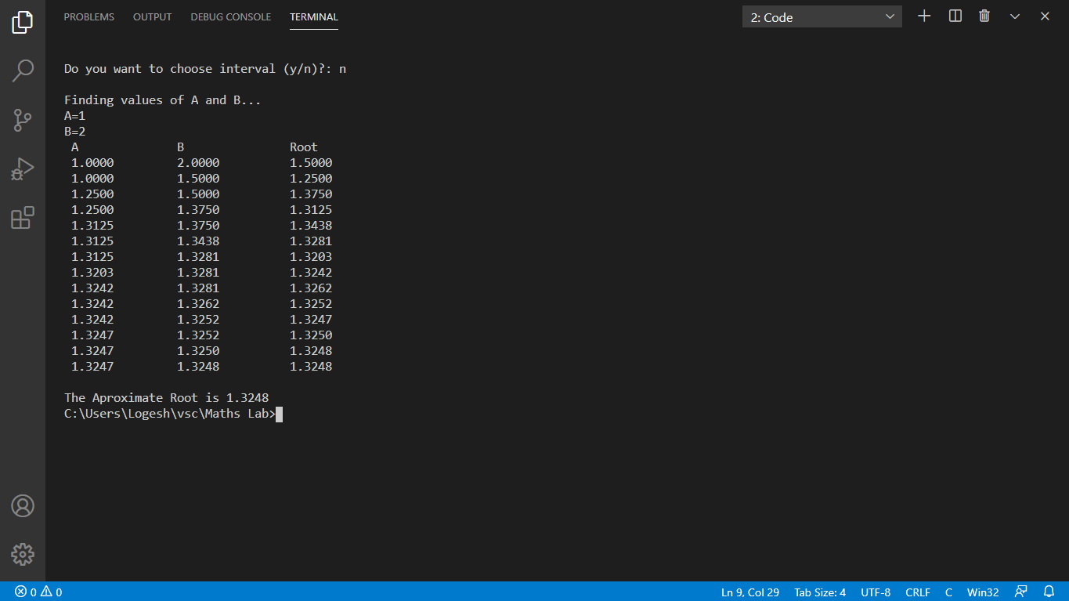

CRITERIA | MAX.MARKS | MARKS OBTAINED
AIM & ALGORITHM | 5
EXECUTION & OUTPUT | 10
VIVA | 5
TOTAL | 20

RESULT:

EX.NO:2 | ROOTS OF NON – LINEAR EQUATION USING NEWTON’S METHOD.
DATE: | ROOTS OF NON – LINEAR EQUATION USING NEWTON’S METHOD.

AIM:

To write a program in “C” Language to implement Newton’s Raphson method.

ALGORITHM :

Step 1. Start the program.
Step 2. Define the function f(x), f’(x)
Step 3. Enter the initial guess of the root , say x0
Step 4. Calculate xn+1 = xn – [f(xn)/ f’(xn)], n = 0, 1, 2, …
Step 5. If |xn+1 – xn| < ϵ, ϵ being prescribed accuracy then go to step 7.
Step 6. Set xn = xn+1 and go to step 4.
Step 7. Print the value of xn.
Step 8. Stop the program.

PROGRAM:

#include<stdio.h>
#include<stdlib.h>
#include<math.h>
#define f(x) ((3*x)-cos(x)-1) //Function
#define f1(x) (3+sin(x)) //Derivative of the function

void main()
{
float a=-1,b=-1,c,prv=-1;
int i;
char ch;
system("cls");
printf("Do you want to choose interval (y/n)?: ");
scanf("%c",&ch);
if (ch=='y'||ch=='Y')
{
printf("Enter value of A and B\n");
scanf("%f%f",&a,&b);
}
else
{
for(i=0;a==-1||b==-1;i++)
{
if(f(0)<0)
{
if(f(i)<0)
a=i;
if(f(i)>0)
b=i;
}
else
{
if(f(i)>0)
a=i;
if(f(i)<0)
b=i;
}
}
printf("\nFinding values of A and B...\nA=%.f\nB=%.f\n",a,b);
}

printf(" Itt\t\t\tRoot\n");

c=(abs(f(a))>=abs(f(b)))?a:b;
i=0;
while((ceil(10000*prv)/10000)!=(ceil(10000*c)/10000))
{
prv=c;
c=(c-(f(c)/f1(c)));
printf(" %d\t\t%.4f\n",i,c);
i++;
}
printf("\nThe Aproximate Root is %.4f",c);
}

INPUT/OUTPUT:

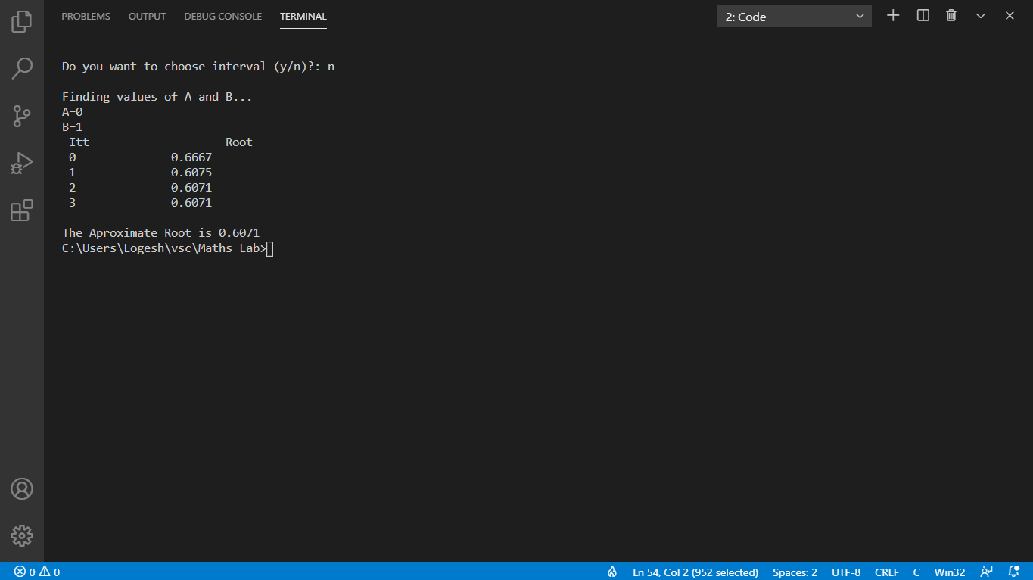

CRITERIA | MAX.MARKS | MARKS OBTAINED
AIM & ALGORITHM | 5
EXECUTION & OUTPUT | 10
VIVA | 5
TOTAL | 20

RESULT:

EX.NO:3 | TO FIND THE LARGEST EIGEN VALUE OF A MATRIX BY POWER - METHOD.
DATE:

AIM:

To write a C program to implement the largest eigen value of a matrix by power - method.

ALGORITHM:

1. Start

2. Read Order of Matrix (n) and Tolerable Error (e)

3. Read Matrix A of Size n x n

4. Read Initial Guess Vector X of Size n x 1

5. Initialize: Lambda_Old = 1

6. Multiply: X_NEW = A * X

7. Replace X by X_NEW

8. Find Largest Element (Lamda_New) by Magnitude from X_NEW

9. Normalize or Divide X by Lamda_New

10. Display Lamda_New and X

11. If |Lambda_Old - Lamda_New| > e then set Lambda_Old = Lamda_New and goto
step (6) otherwise goto step (12)

12. Stop

PROGRAM:

#include<stdio.h>
#include<conio.h>
#include<math.h>
#include<stdlib.h>

int cp(float z[],float p[],int n)
{
if (n==0)
return 0;
else if(z[n]==p[n])
{
n--;
cp(z,p,n);
return 1;
}
else
return 0;
}

void main()
{

int i,j,n;
float A[40][40],x[40],z[40],p[40],max;
system("cls");
printf("\nEnter the order of matrix:");
scanf("%d",&n);
printf("\nEnter matrix elements row-wise\n");
for(i=1; i<=n; i++)
{
for(j=1; j<=n; j++)
{
printf("A[%d][%d]=", i,j);
scanf("%f",&A[i][j]);
}
}
printf("\nEnter the column vector\n");
for(i=1; i<=n; i++)
{
printf("X[%d]=",i);
scanf("%f",&x[i]);
}
while(1)
{
for(i=1; i<=n; i++)
{
p[i]=z[i];
}
for(i=1; i<=n; i++)
{
z[i]=0;
for(j=1; j<=n; j++)
{
z[i]=z[i]+A[i][j]*x[j];
}
}
max=fabs(z[1]);
for(i=2; i<=n; i++)
{
if((fabs(z[i]))>max)
max=fabs(z[i]);
}
for(i=1; i<=n; i++)
{
z[i]=z[i]/max;
}

for(i=1; i<=n; i++)
{
z[i]=round(10*z[i])/10;
x[i]=z[i];
}
if(cp(z,p,n)==1)
break;
}
printf("\n The required eigen value is %f",round(max));
printf("\n\nThe required eigen vector is :\n");
for(i=1; i<=n; i++)
{
printf("%f\t",z[i]);
}
getch();
}
INPUT/OUTPUT:

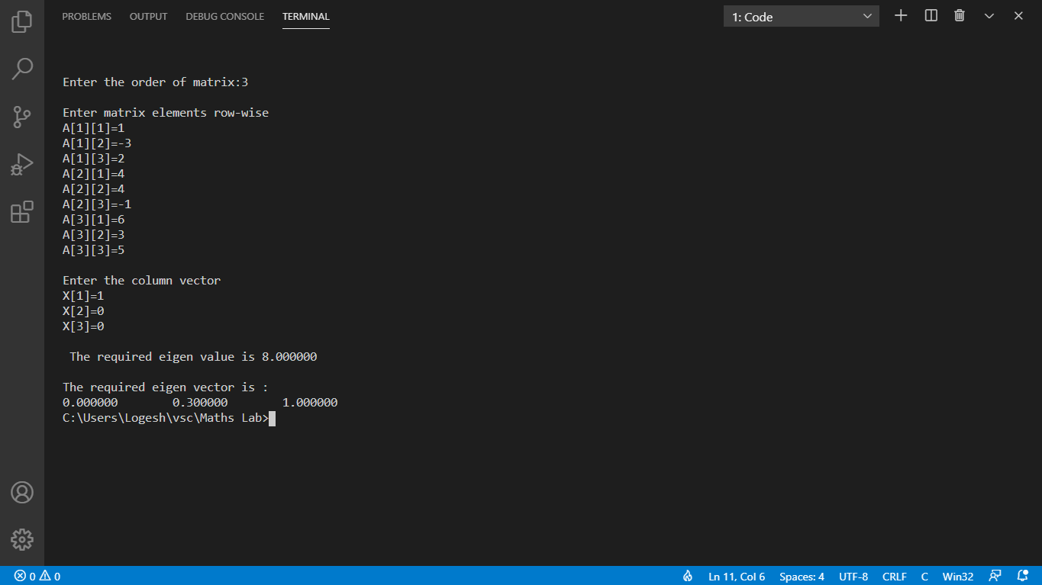

CRITERIA | MAX.MARKS | MARKS OBTAINED
AIM & ALGORITHM | 5
EXECUTION & OUTPUT | 10
VIVA | 5
TOTAL | 20

RESULT:

EX.NO:4 | SOLVE THE SYSTEM OF LINEAR EQUATIONS USING GAUSS - ELIMINATION METHOD.
DATE:

AIM:

To write a C program to implement the system of linear equations using gauss - elimination method.

ALGORIHTM:

1. Start

2. Read Number of Unknowns: n

3. Read Augmented Matrix (A) of n by n+1 Size

4. Transform Augmented Matrix (A) to Upper Trainagular Matrix by Row Operations.

5. Obtain Solution by Back Substitution.

6. Display Result.

7. Stop

PROGRAM:

#include<stdio.h>
#include<conio.h>
#include<math.h>
#include<stdlib.h>

int main()
{

int i,j,k,n;
float a[10][10], x[10], r;
system("cls");

printf("Enter the values:\n\n");
n=3;
for(i=1;i<=n;i++)
{
for(j=1;j<=n+1;j++)
{
printf("a[%d][%d] = ",i,j);
scanf("%f", &a[i][j]);
}
}
for(i=1;i<=n-1;i++)
{
if(a[i][i] == 0.0)
{
printf("Error");
exit(0);
}
for(j=i+1;j<=n;j++)
{
r = a[j][i]/a[i][i];

for(k=1;k<=n+1;k++)
{
a[j][k] = a[j][k] - r*a[i][k];
}
}
}
x[n] = a[n][n+1]/a[n][n];

for(i=n-1;i>=1;i--)
{
x[i] = a[i][n+1];
for(j=i+1;j<=n;j++)
{
x[i] = x[i] - a[i][j]*x[j];
}
x[i] = x[i]/a[i][i];
}
printf("\nAnswer:\n");

printf("x = %0.3f\n", x[1]);
printf("y = %0.3f\n", x[2]);
printf("z = %0.3f\n", x[3]);

return(0);
}

INPUT/OUTPUT:

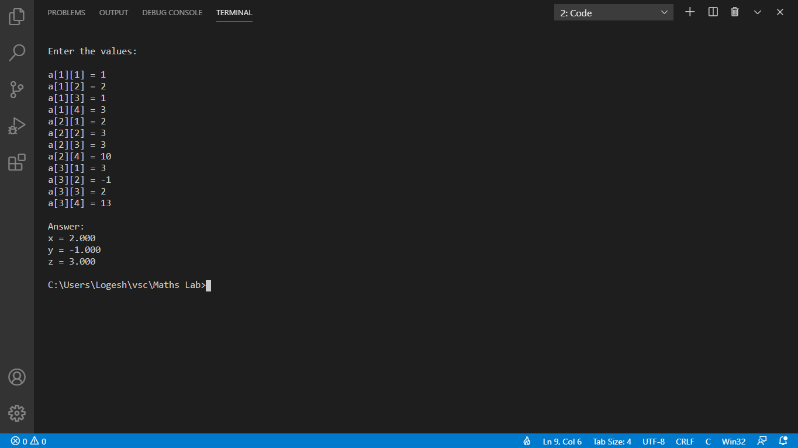

CRITERIA | MAX.MARKS | MARKS OBTAINED
AIM & ALGORITHM | 5
EXECUTION & OUTPUT | 10
VIVA | 5
TOTAL | 20

RESULT:

EX.NO:5 | SOLVE THE SYSTEM OF LINEAR EQUATIONS USING GAUSS - JORDAN METHOD
DATE:

AIM:

To write a C program to implement the system of linear equations using gauss - jordan method.

ALGORITHM:

1. Start

2. Read Number of Unknowns: n

3. Read Augmented Matrix (A) of n by n+1 Size

4. Transform Augmented Matrix (A) to Diagonal Matrix by Row Operations.

5. Obtain Solution by Making All Diagonal Elements to 1.

6. Display Result.

7. Stop

PROGRAM:

#include<stdio.h>
#include<math.h>
int main()
{
float a[10][ 10], x[10], ratio;
int i,j,k,n;
printf("Enter number of unknowns: ");
scanf("%d", &n);
printf("Enter coefficients of Augmented Matrix:\n");
for(i=1;i<=n;i++)
{
for(j=1;j<=n+1;j++)
{
printf("a[%d][%d] = ",i,j);
scanf("%f", &a[i][j]);
}
}
for(i=1;i<=n;i++)
{
if(a[i][i] == 0.0)
{
printf("Mathematical Error!");
exit(0);
}
for(j=1;j<=n;j++)
{
if(i!=j)
{
ratio = a[j][i]/a[i][i];
for(k=1;k<=n+1;k++)
{
a[j][k] = a[j][k] - ratio*a[i][k];
}
}
}
}
for(i=1;i<=n;i++)
{
x[i] = a[i][n+1]/a[i][i];
}
/* Displaying Solution */
printf("\nSolution:\n");
for(i=1;i<=n;i++)
{
printf("x[%d] = %0.3f\n",i, x[i]);
}
getch();
return(0);
}

INPUT/OUTPUT:

CRITERIA | MAX.MARKS | MARKS OBTAINED
AIM & ALGORITHM | 5
EXECUTION & OUTPUT | 10
VIVA | 5
TOTAL | 20

RESULT:

EX.NO:6 | SOLVE THE SYSTEM OF LINEAR EQUATIONS USING GAUSS - SEIDAL ITERATION METHOD.
DATE:

AIM:
To write a C program to implement the system of linear equations using gauss - seidal iteration method.

ALGORITHM:

set x = X₀
repeat
maxdiff: = 0
for i := 1 to n
y:=(bi−∑j=1j≠inaijxj)/aii
if | y − x_{i} | < maxdiff then maxdiff: = | y − x_{i} |
x_{i} := y
next i
until maxdiff > ∈
[x is the refined solution.

PROGRAM:

#include<stdio.h>
#include<conio.h>
#include<math.h>
#include<stdlib.h>
#define f1(x,y,z) (85-6*y-z)/27
#define f2(x,y,z) (72-6*x-2*z)/15
#define f3(x,y,z) (110-x+y)/54
int main()
{
float x0, y0, z0, x1, y1, z1;
int count=1;
system("cls");
printf("\nCount\tx\ty\tz\n");
do
{
x0 = x1;
y0 = y1;
z0 = z1;
x1 = f1(x1,y1,z1);
y1 = f2(x1,y1,z1);
z1 = f3(x1,y1,z1);
printf("%d\t%0.4f\t%0.4f\t%0.4f\n",count, x1,y1,z1);
count++;
}while(x0!=x1 && y0!=y1 && z0!=z1);
printf("\nSolution: x=%0.3f, y=%0.3f and z = %0.3f\n",x1,y1,z1);
getch();
return 0;
}
NPUT AND OUTPUT:

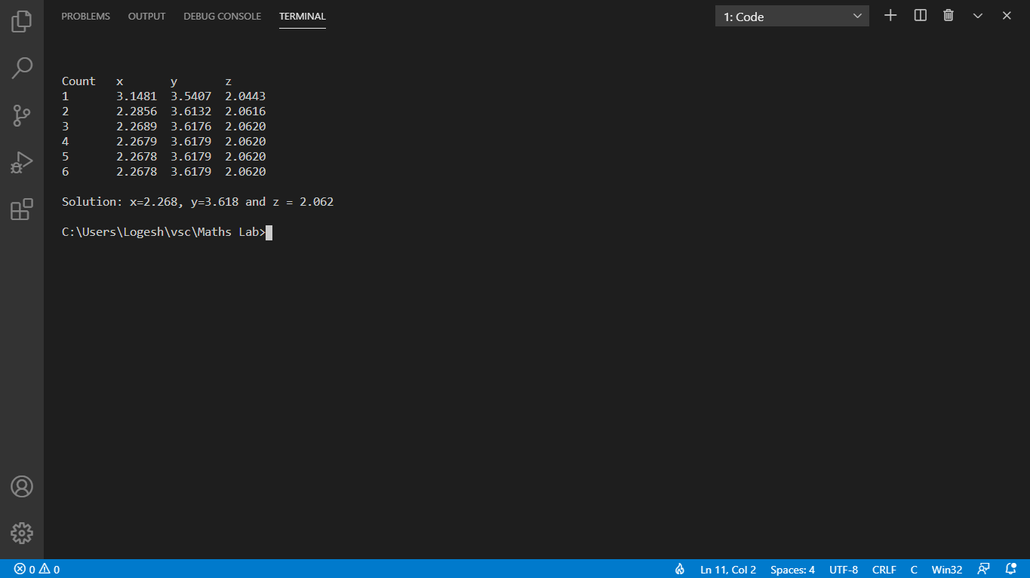

CRITERIA | MAX.MARKS | MARKS OBTAINED
AIM & ALGORITHM | 5
EXECUTION & OUTPUT | 10
VIVA | 5
TOTAL | 20

RESULT:

EX.NO:7 | FIND AREA BY USING TRAPEZOIDAL RULE
DATE: | FIND AREA BY USING TRAPEZOIDAL RULE

AIM:
To write a C program to implement find area by using trapezoidal rule.

ALGORITHM:

1. Start

2. Define function f(x)

3. Read lower limit of integration, upper limit of integration and number of sub interval

4. Calcultae: step size = (upper limit - lower limit)/number of sub interval

5. Set: integration value = f(lower limit) + f(upper limit)

6. Set: i = 1

7. If i > number of sub interval then goto

8. Calculate: k = lower limit + i * h

9. Calculate: Integration value = Integration Value + 2* f(k)

10. Increment i by 1 i.e. i = i+1 and go to step 7

11. Calculate: Integration value = Integration value * step size/2

12. Display Integration value as required answer

13. Stop

PROGRAM:

#include<stdio.h>
#include<conio.h>
#include<math.h>
/* Define function here */
#define f(x) 1/(1+pow(x,2))
int main()
{
float lower, upper, integration=0.0, stepSize, k;
int i, subInterval;
clrscr();
/* Input */
printf("Enter lower limit of integration: ");
scanf("%f", &lower);
printf("Enter upper limit of integration: ");
scanf("%f", &upper);
printf("Enter number of sub intervals: ");
scanf("%d", &subInterval);

/* Calculation */
/* Finding step size */
stepSize = (upper - lower)/subInterval;

/* Finding Integration Value */
integration = f(lower) + f(upper);
for(i=1; i<= subInterval-1; i++)
{
k = lower + i*stepSize;
integration = integration + 2 * f(k);
}
integration = integration * stepSize/2;
printf("\nRequired value of integration is: %.3f", integration);
getch();
return 0;
}
INPUT AND OUTPUT:

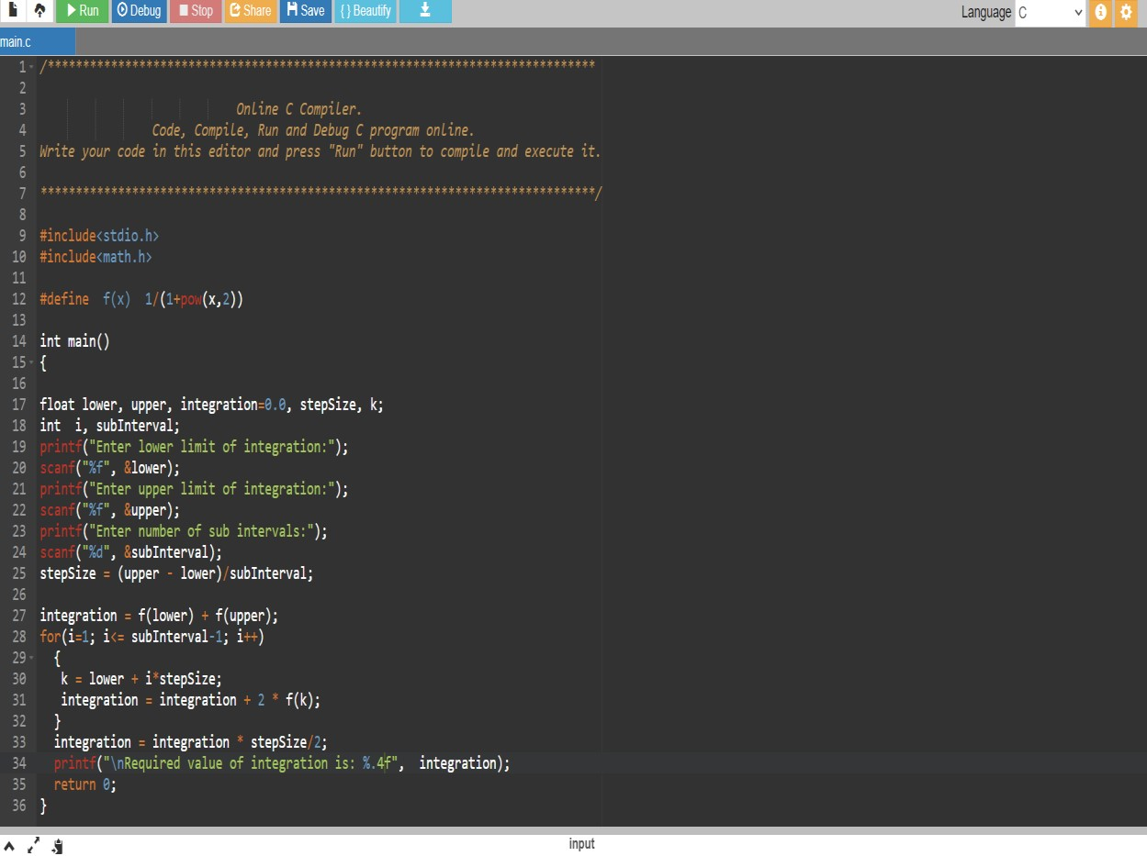

CRITERIA | MAX.MARKS | MARKS OBTAINED
AIM & ALGORITHM | 5
EXECUTION & OUTPUT | 10
VIVA | 5
TOTAL | 20

RESULT:

EX.NO:8 | FIND AREA BY USING SIMPSON’S RULE
DATE: | FIND AREA BY USING SIMPSON’S RULE

AIM:

To write a C program to implement find area by using simpson’s 1/3 rule.

ALGORITHM:

1. Start

2. Define function f(x)

3. Read lower limit of integration, upper limit of
integration and number of sub interval

4. Calcultae: step size = (upper limit - lower limit)/number of sub interval

5. Set: integration value = f(lower limit) + f(upper limit)

6. Set: i = 1

7. If i > number of sub interval then goto

8. Calculate: k = lower limit + i * h

9. If i mod 2 =0 then
Integration value = Integration Value + 2* f(k)
Otherwise
Integration Value = Integration Value + 4 * f(k)
End If

10. Increment i by 1 i.e. i = i+1 and go to step 7

11. Calculate: Integration value = Integration value * step size/3

12. Display Integration value as required answer

13. Stop

PROGRAM:

#include<stdio.h>
#include<conio.h>
#include<math.h>

/* Define function here */
#define f(x) 1/(1+x*x)
int main()
{
float lower, upper, integration=0.0, stepSize, k;
int i, subInterval;
clrscr();
/* Input */
printf("Enter lower limit of integration: ");
scanf("%f", &lower);
printf("Enter upper limit of integration: ");
scanf("%f", &upper);
printf("Enter number of sub intervals: ");
scanf("%d", &subInterval);

/* Calculation */
/* Finding step size */
stepSize = (upper - lower)/subInterval;

/* Finding Integration Value */
integration = f(lower) + f(upper);
for(i=1; i<= subInterval-1; i++)
{
k = lower + i*stepSize;
if(i%2==0)
{
integration = integration + 2 * f(k);
}
else
{
integration = integration + 4 * f(k);
}
}
integration = integration * stepSize/3;
printf("\nRequired value of integration is: %.3f", integration);
getch();
return 0;
}
INPUT/OUTPUT:
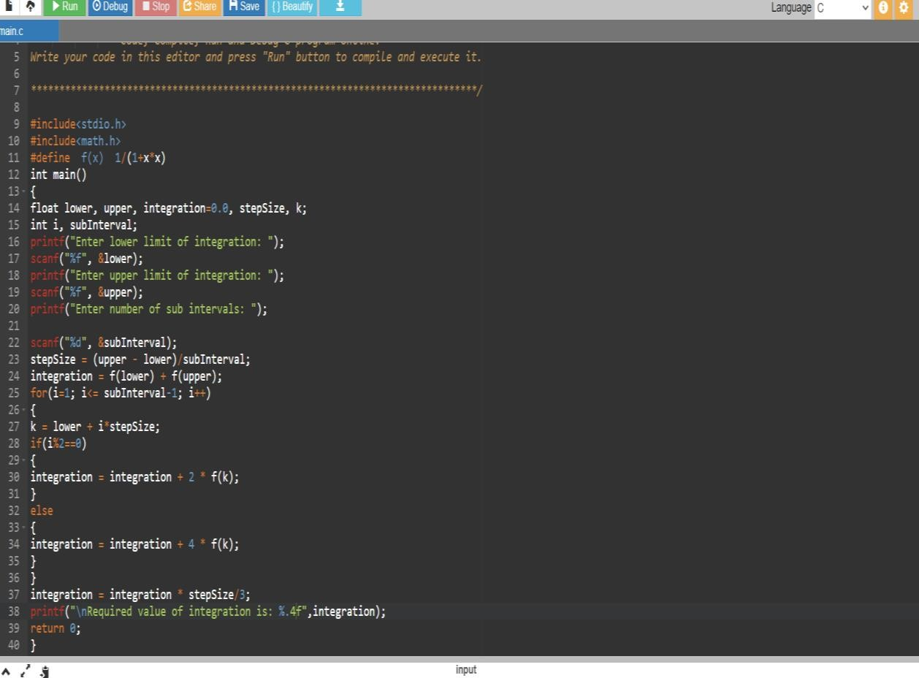

CRITERIA | MAX.MARKS | MARKS OBTAINED
AIM & ALGORITHM | 5
EXECUTION & OUTPUT | 10
VIVA | 5
TOTAL | 20

RESULT:

EX.NO:9 | FIND AREA BY USING SIMPSON’S 3/8 RULE.
DATE: | FIND AREA BY USING SIMPSON’S 3/8 RULE.

AIM:
To write a program in C to implement find area by using simpson’s 3/8 rule.

ALGORITHM:

1. Start

2. Define function f(x)

3. Read lower limit of integration, upper limit of integration and number of sub interval

4. Calcultae: step size = (upper limit - lower limit)/number of sub interval

5. Set: integration value = f(lower limit) + f(upper limit)

6. Set: i = 1

7. If i > number of sub interval then goto

8. Calculate: k = lower limit + i * h

9. If i mod 3 =0 then
Integration value = Integration Value + 2* f(k)
Otherwise
Integration Value = Integration Value + 3 * f(k)
End If

10. Increment i by 1 i.e. i = i+1 and go to step 7

11. Calculate: Integration value = Integration value * step size*3/8

12. Display Integration value as required answer

13. Stop

PROGRAM:

#include<stdio.h>
#include<conio.h>
#include<math.h>
/* Define function here */
#define f(x) 1/(1+x*x)
int main()
{
float lower, upper, integration=0.0, stepSize, k;
int i, subInterval;
clrscr();
/* Input */
printf("Enter lower limit of integration: ");
scanf("%f", &lower);
printf("Enter upper limit of integration: ");
scanf("%f", &upper);
printf("Enter number of sub intervals: ");
scanf("%d", &subInterval);

/* Calculation */
/* Finding step size */
stepSize = (upper - lower)/subInterval;

/* Finding Integration Value */
integration = f(lower) + f(upper);
for(i=1; i<= subInterval-1; i++)
{
k = lower + i*stepSize;
if(i%3 == 0)
{
integration = integration + 2 * f(k);
}
else
{
integration = integration + 3 * f(k);
}
}
integration = integration * stepSize*3/8;
printf("\nRequired value of integration is: %.3f", integration);
getch();
return 0;
}
INPUT/OUTPUT:

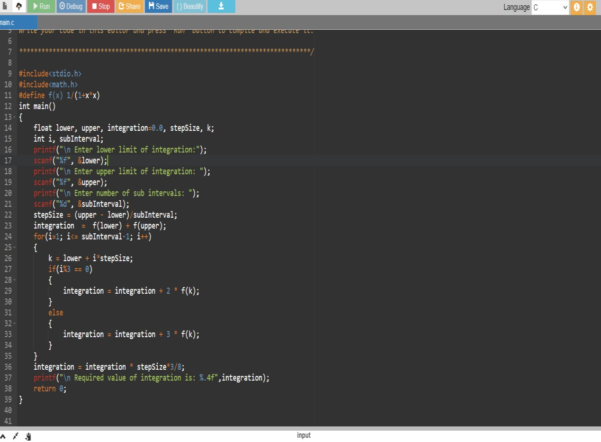

CRITERIA | MAX.MARKS | MARKS OBTAINED
AIM & ALGORITHM | 5
EXECUTION & OUTPUT | 10
VIVA | 5
TOTAL | 20

RESULT:

EX.NO:10 | TO FIND THE NUMERICAL SOLUTION OF HEAT EQUATION.
DATE: | TO FIND THE NUMERICAL SOLUTION OF HEAT EQUATION.

AIM:
To write a program in C to implement to find the numerical solution of heat equation.

ALGORITHM:

PROGRAM:

#include<stdio.h>
#include<math.h>
#define X 8
#define T 5
float fun(int a)
{
return(4*a-(a*a)/2.0);
}
main()
{
float u[X+1][T+1], h=1.0, k=0.0125,c,al,us,ue;
int j,i;
printf("\n Enter the square of 'c' :");
scanf("%f",&c);
al=c*k/pow(h,2);
printf(" Enter the value of u[0, t] :");
scanf("%f",&us);
printf(" Enter the value of u[%d,t]:", X);
scanf("%f",&ue);
for(i=0;i<=T;i++)
u[0][i]=u[X][i]=us;
for(j=1;j<=X-1;j++)
u[j][0]=fun(j);
for(i=0;i<=T-1;i++)
for(j=1;j<=X-1;j++)
u[j][i+1]=al*u[j-1][i]+(1-2*al)*u[j][i]+al*u[j+1][i];
printf(" The value of alpha is %4.2f\n",al);
printf(" The value of u[j,i] are:\n ");
for(i=0;i<T;i++)
{
for(j=0;j<X;j++)
printf("%7.4f\t",u[j][i]);
printf("\n");
}
}

INPUT/OUTPUT:

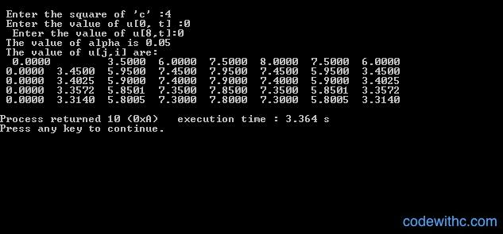

CRITERIA | MAX.MARKS | MARKS OBTAINED
AIM & ALGORITHM | 5
EXECUTION & OUTPUT | 10
VIVA | 5
TOTAL | 20

RESULT:

EX.NO:11 | QUEUE USING LINKED LIST
DATE: | QUEUE USING LINKED LIST

AIM:
To write a program in C to implement Queue using Linked List.

ALGORITHM:

Algorithm for Queue using Linked List:
INSERT()
{
tmp=(struct node*)malloc(sizeof(struct node)); // allocate memory
tmp->info=added_item; // input the item into queue
tmp->link=NULL; // set node links
if(front==NULL)
// Queue is empty
front=tmp;
else
rear->link=tmp;
rear=tmp;
}
DELETE()
{
if(front==NULL)
{
// queue empty condition
}
else
{
tmp=front;
front=front->link; // item deleted
free(tmp);
}
}
DISPLAY()
{
struct node*ptr;
ptr=front;
if(front==NULL)
Write("\n Queue is empty.");
else
{
Write("\n Queue elements. \n");
while(ptr!=NULL)
{
Write(" %d ",ptr->info);
ptr=ptr->link;
}
Write("\n");
}// end of else
}// end of display

PROGRAM:

INPUT/OUTPUT:

CRITERIA | MAX.MARKS | MARKS OBTAINED
AIM & ALGORITHM | 5
EXECUTION & OUTPUT | 10
VIVA | 5
TOTAL | 20

RESULT:

EX.NO:12 | DOUBLY LINKED LIST
DATE: | DOUBLY LINKED LIST

AIM:
To write a program in C to implement Doubly Linked List.

ALGORITHM:
Algorithm for Doubly Linked List:
INSERT AT FIRST(X)
{
struct node *tmp;
tmp=malloc(sizeof(struct node));// memory allocation
tmp->prev=NULL;
tmp->info=num;
tmp->next=start;
start->prev=tmp;//set node links
start=tmp;
}
INSERT AT MIDDLE(X)
{
struct node *tmp,*q;
int i;
q=start;
for(i=0;i<(c-1);i++)
{
q=q->next;
if(q==NULL)
{
return;
}
}
tmp=malloc(sizeof(struct node));
tmp->info=num;
q->next->prev=tmp;
tmp->next=q->next;
tmp->prev=q;
q->next=tmp;
}

DELETE (X)
struct node *tmp,*q;
/ *if(start==NULL)
{
printf("\n List is empty! ");
return;
} */
if(start->info==num)
{
tmp=start;
start=start->next;
start->prev=NULL;
free(tmp);
return;
}
q=start;
while(q->next->info!=num ) // Element deleted in between
{
q=q->next;
}
if((q->next->info==num)&&(q->next->next==NULL)) // Last element deleted
{
tmp=q->next;
free(tmp);
q->next=NULL;
return;
}
if(q->next->info==num)
{
tmp=q->next;
q->next=tmp->next;
tmp->next->prev=q;
free(tmp);
return;
}
printf("\n Element %d not found. \n",num);
DISPLAY
{
struct node *q;
if(start==NULL)
{

printf("\n List is empty.");
return;
}
q=start;
printf("\n List is: ");
while(q!=NULL)
{
printf(" %d ",q->info);
q=q->next;
}
printf("\n");
} // End of display()
COUNT()
{
struct node *q=start;
int cnt=0;
while(q!=NULL)
{
q=q->next;
cnt++;
}
printf("\n Number of elements are %d ",cnt);
} // End of count
REVERSE()
rev()
{
struct node *p1,*p2;
p1=start;
p2=p1->next;
p1->next=NULL;
p1->prev=p2;
while(p2!=NULL)
{
p2->prev=p2->next;
p2->next=p1;
p1=p2;
p2=p2->prev; // next of p2 changed to prev
}
start=p1;
} // end of rev()

PROGRAM:

INPUT/OUTPUT:

CRITERIA | MAX.MARKS | MARKS OBTAINED
AIM & ALGORITHM | 5
EXECUTION & OUTPUT | 10
VIVA | 5
TOTAL | 20

RESULT:

EX.NO:13 | TREE TRAVERSALS
DATE: | TREE TRAVERSALS

AIM:
To write a program in C to implement Tree Traversals

ALGORITHM:

Algorithm for Tree Traversals:
PREORDER(STRUCT NODE *R)
{
if(r!=NULL)
{
printf("\t %d",r->data);
preorder(r->left);
preorder(r->right);
}
}
INORDER (STRUCT NODE *R)
{
if(r!=NULL)
{
inorder(r->left);
Write("\t %d",r->data);
inorder(r->right);
}
}
POSTORDER(STRUCT NODE *R)
{ if(r!=NULL)
{ postorder(r->left);
postorder(r->right);
printf("\t %d",r->data);
}}

PROGRAM:

INPUT/OUTPUT:

CRITERIA | MAX.MARKS | MARKS OBTAINED
AIM & ALGORITHM | 5
EXECUTION & OUTPUT | 10
VIVA | 5
TOTAL | 20

RESULT:

EX.NO:14 | BREATH FIRST SEARCH
DATE: | BREATH FIRST SEARCH

AIM:
To write a program in C to implement Breath First Search.

ALGORITHM:

Algorithm for Breath First Search:
ALGORITHM BFS(INT V)
{
for(i=1;i<=n;i++)
vis[i]=0;
vis[v]=1;
u=v;
while(v<=n)
{
front=0;
rear=0;
for(i=1;i<=n;i++)
q[i]=0;
for(w=1;w<=n;w++)
{
front++;
q[front]=w;
vis[w]=1;
}
}
}
if((rear==0)&&(front==0))
return;
else
{
while(rear<front)
{
rear++;
u=q[rear];
printf(" -> %d",u);
}
}
v++;
}
}

PROGRAM:

INPUT/OUTPUT:

CRITERIA | MAX.MARKS | MARKS OBTAINED
AIM & ALGORITHM | 5
EXECUTION & OUTPUT | 10
VIVA | 5
TOTAL | 20

RESULT:

EX.NO:15 | DEPTH FIRST SEARCH
DATE: | DEPTH FIRST SEARCH

AIM:
To write a program in C to implement Depth First Search.
ALGORITHM:

ALGORITHM DEPTH FIRST SEARCH (INT V)
{
int w;
vis[v]=1;
printf(" -> %d",v);
for(w=1;w<=n;w++)
{
if(vis[w]==0)
{
if(adj[v][w]==1)
{
dfs(w);
}
}
}
}

PROGRAM:
INPUT/OUTPUT:

CRITERIA | MAX.MARKS | MARKS OBTAINED
AIM & ALGORITHM | 5
EXECUTION & OUTPUT | 10
VIVA | 5
TOTAL | 20

RESULT:

EX.NO:16 | SHELL SORT
DATE: | SHELL SORT

AIM:
To write a program in C to implement Shell Sort.
ALGORITHM:

Algorithm for Shell Sort:
shellSort()
A : array of items
/* calculate interval*/
while interval < A.length /3 do:
interval = interval * 3 + 1
end while

while interval > 0 do:

for outer = interval; outer < A.length; outer ++ do:

/* select value to be inserted */
valueToInsert = A[outer]
inner = outer;

/*shift element towards right*/
while inner > interval -1 && A[inner - interval] >= valueToInsert do:
A[inner] = A[inner - interval]
inner = inner - interval
end while

/* insert the number at hole position */
A[inner] = valueToInsert

end for

/* calculate interval*/
interval = (interval -1) /3;

end while
end procedure

PROGRAM:

INPUT / OUTPUT:

CRITERIA | MAX.MARKS | MARKS OBTAINED
AIM & ALGORITHM | 5
EXECUTION & OUTPUT | 10
VIVA | 5
TOTAL | 20

RESULT:

